COMMUNICATION DIAGRAM

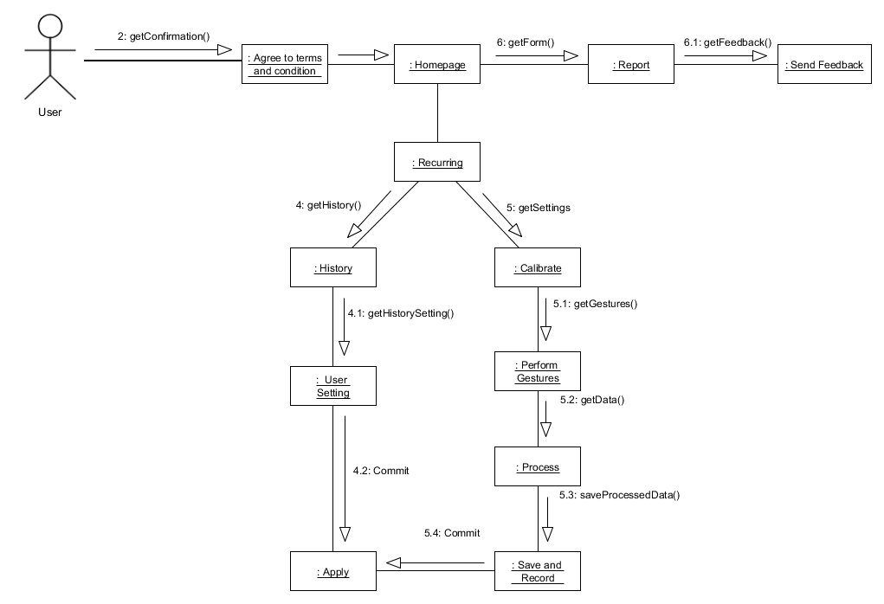

INTERACTION DIAGRAM

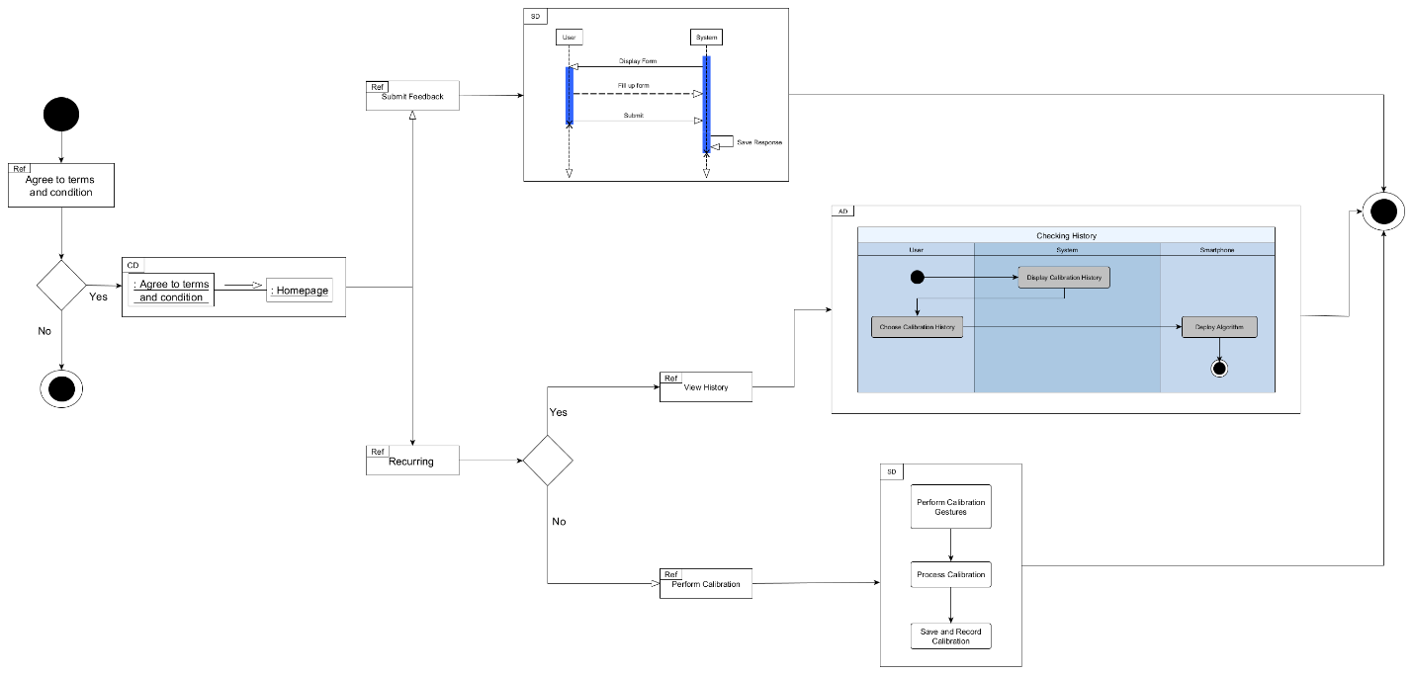

OBJECT DIAGRAM

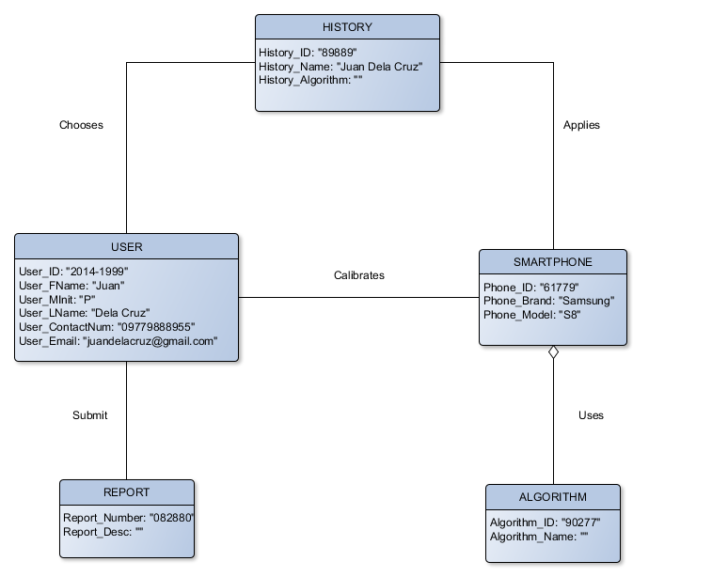

SEQUENCE DIAGRAM – REPORT

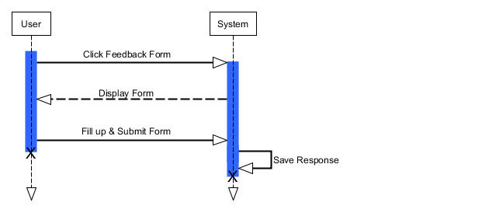

SEQUENCE DIAGRAM – TOUCH CALIBRATOR WITH HISTORY

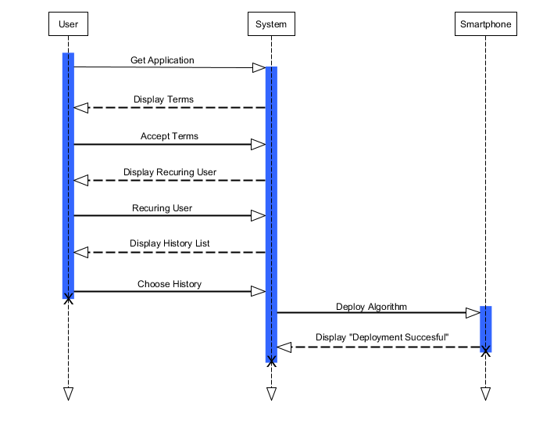

SEQUENCE DIAGRAM – TOUCH CALIBRATOR WITHOUT HISTORY

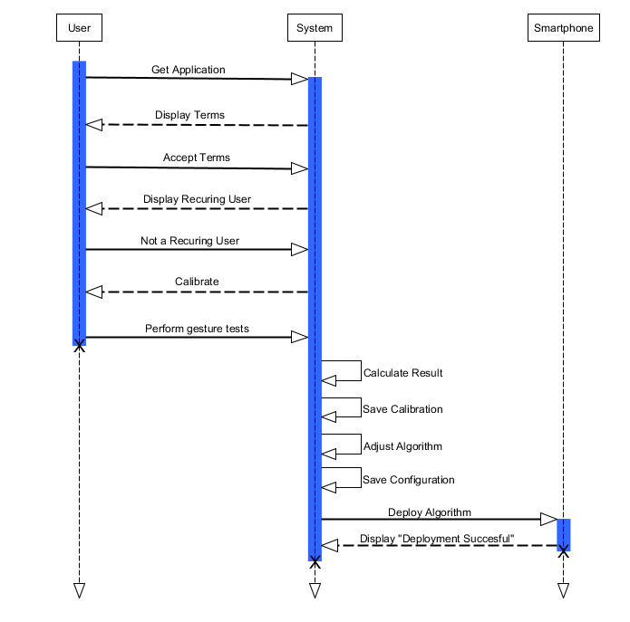

STATE DIAGRAM

